智能纪要：56、男孩自述：小孩如何看待学习 2026年1月22日
会议主题：56、男孩自述：小孩如何看待学习
上传时间：1月22号（周四） 22:27 （GMT+08）

智能纪要由 AI 生成，可能不准确，请谨慎甄别后使用

总结
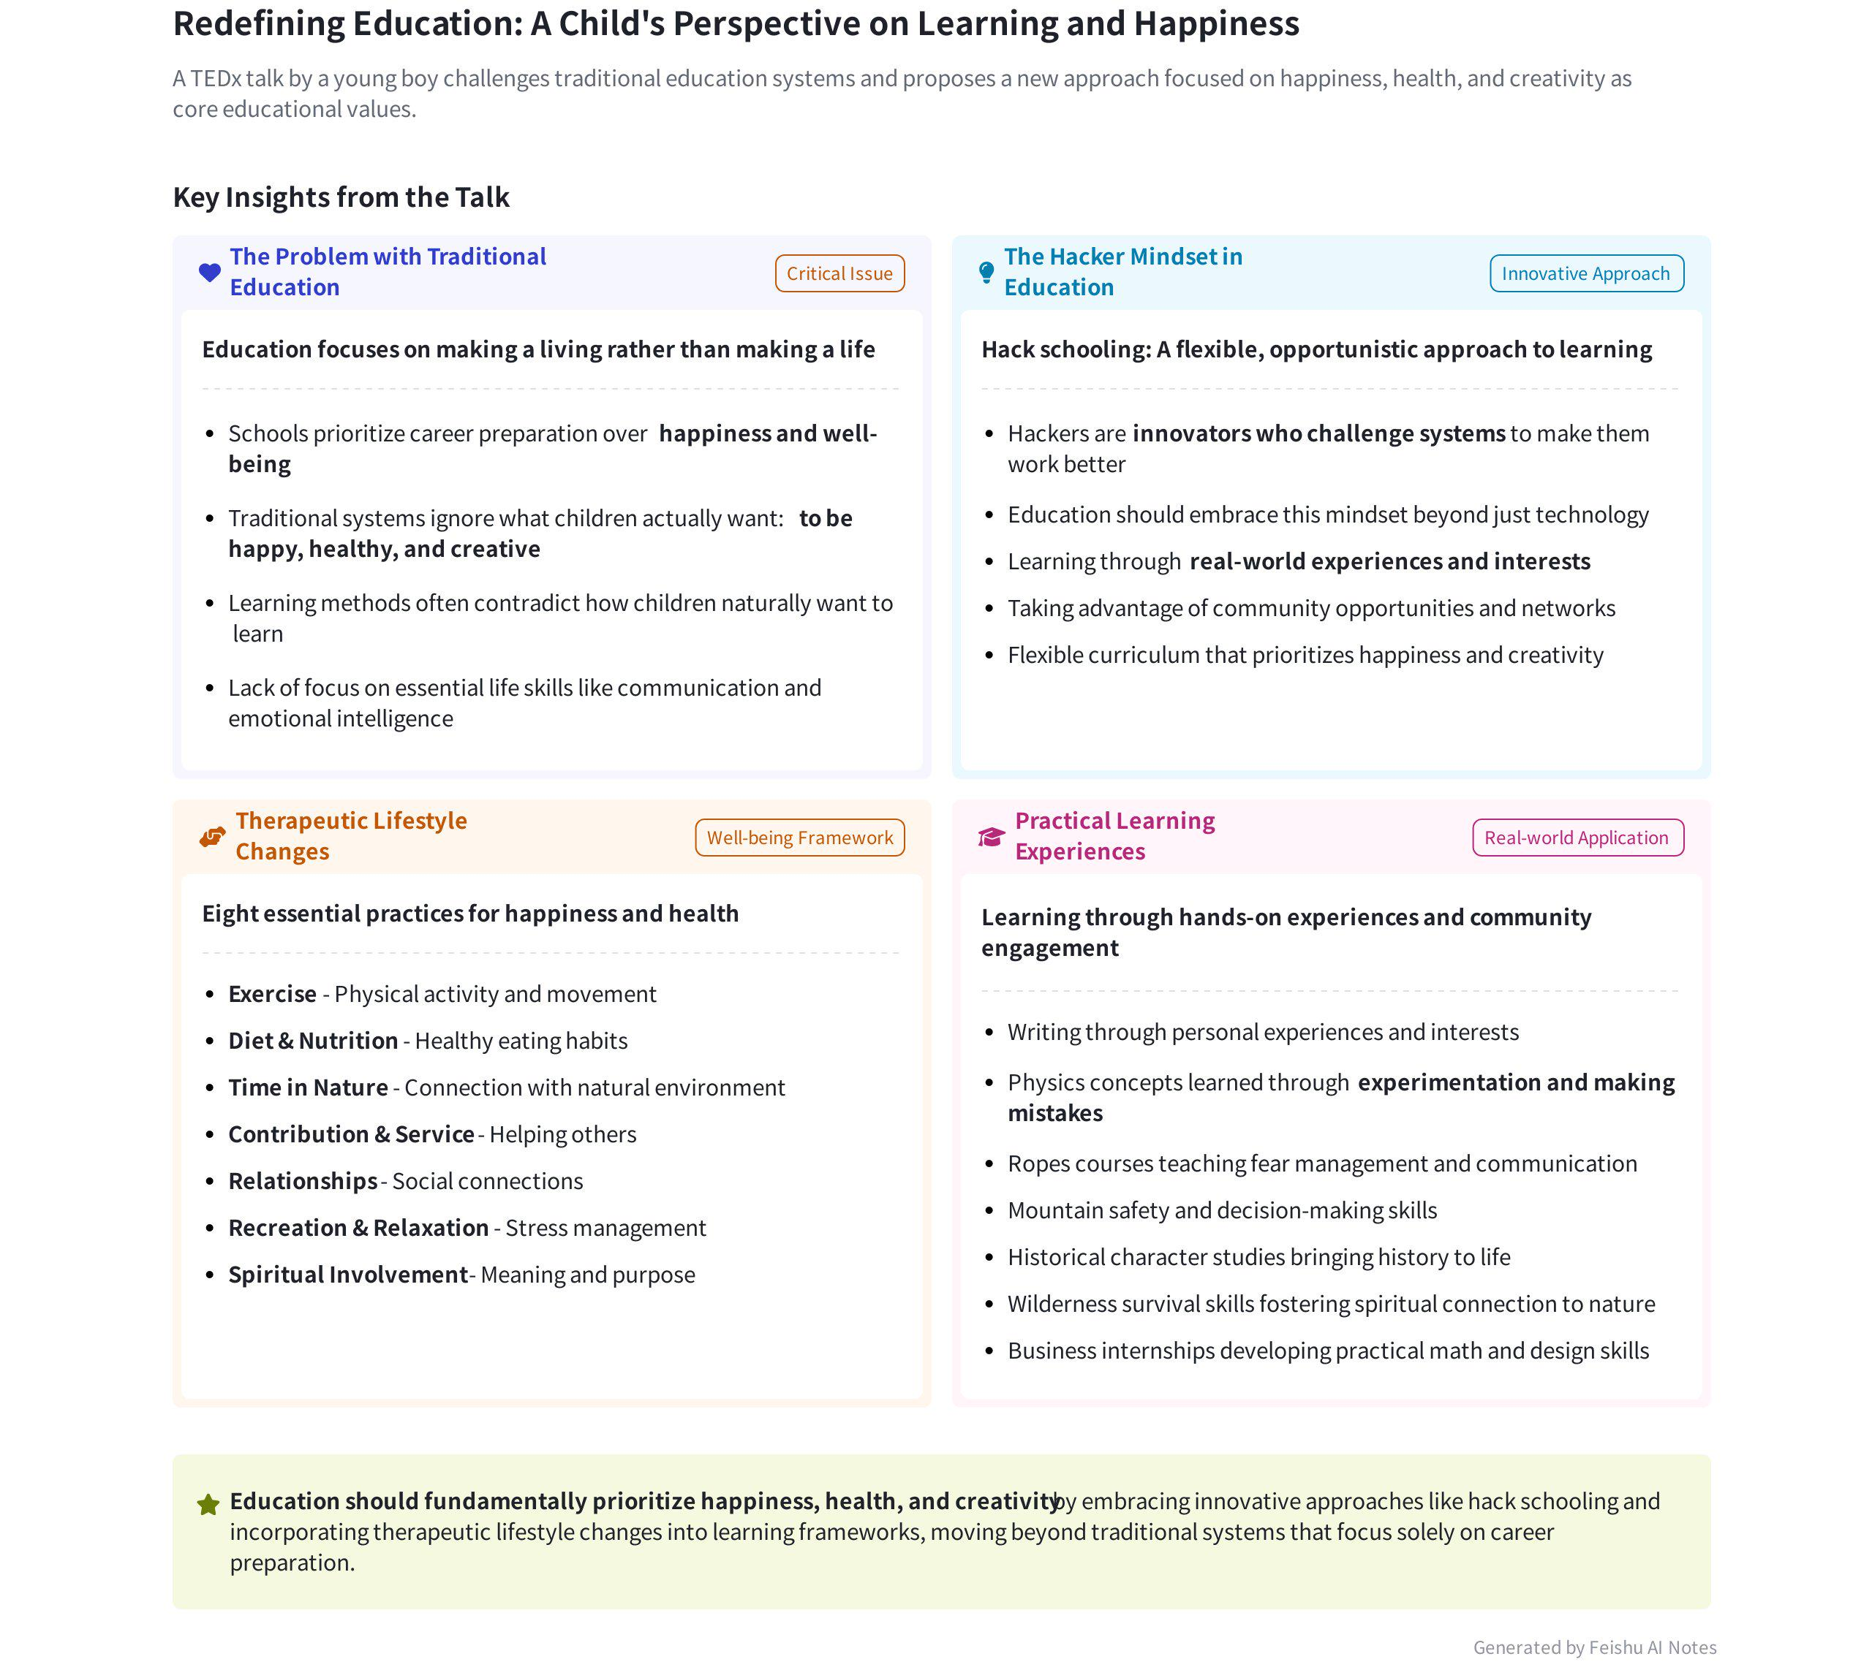
The meeting discussed a video featuring an 11 - year - old boy's views on learning, happiness, and education. The boy advocates for a "hacker" approach to learning and emphasizes the importance of happiness. The meeting also highlighted the lack of communication skills education in traditional schools. Content follows:
- Learning Motivation and Approach
- Discrepancy between Children and Adults  - Mismatch in Learning Preferences: The boy pointed out that what he likes to learn differs from what adults assume. He loves learning but in his preferred way, not the one imposed by traditional schools. This mismatch is a simple reason for the lack of learning motivation.  - The "Hacker" Learning Method: The boy introduced the concept of "hacking" education, which is a flexible and opportunistic way of learning. It takes advantage of community resources and personal networks, focusing on making learning a process of achieving happiness, health, and creativity. | 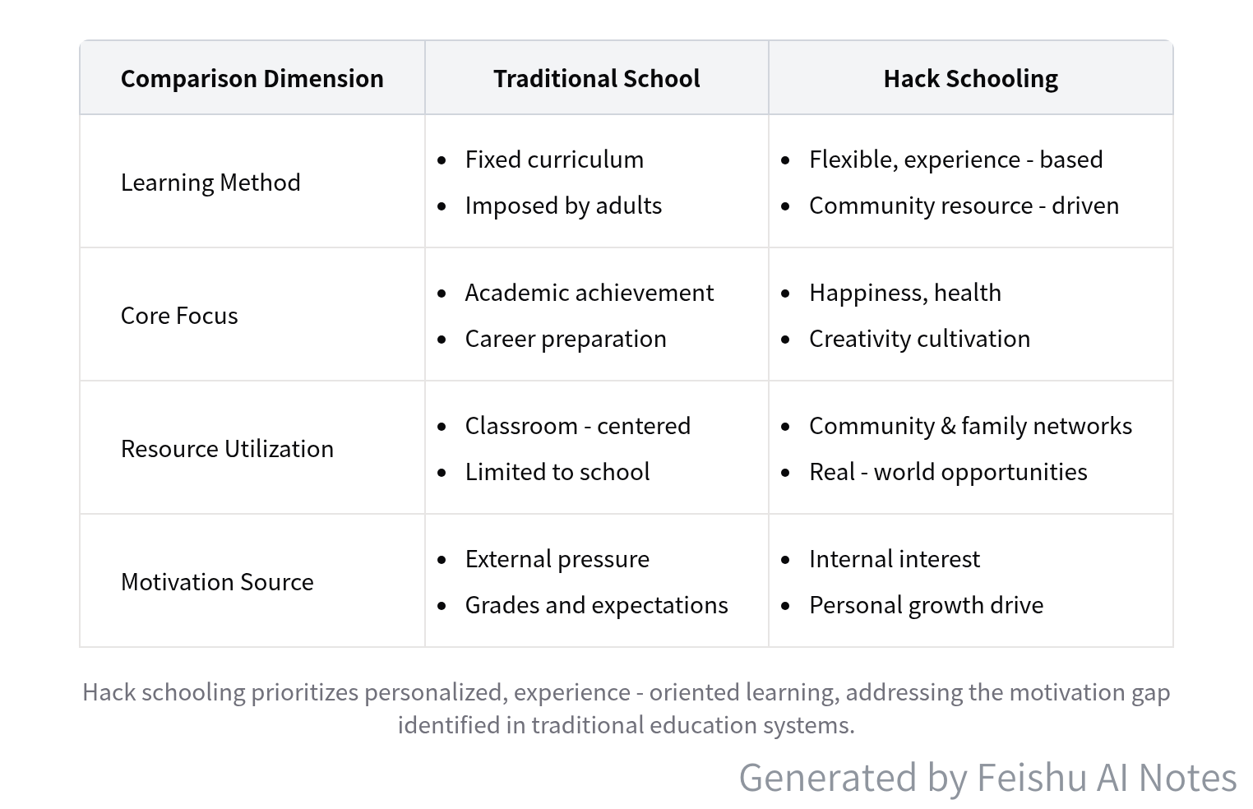  Traditional School vs. Hack Schooling Comparison
- Inspiration for Adults: Speaker 1 emphasized that adults often rely on experts' opinions and ignore children's own voices. They should seriously consider children's feelings and preferences in the learning process.
- Happiness as the Core  - The Boy's View: When asked what he wants to be when he grows up, the boy simply said he wants to be happy. He believes that being happy is the most important thing in life, regardless of future career or other aspects.  - Relevance to Real Life: Speaker 1 related this to the concept of employment and daily life, stating that all pursuits, including employment,升学, and even gossip - watching, are ultimately for the sake of happiness. People often over - complicate things and deviate from this fundamental goal. |  | 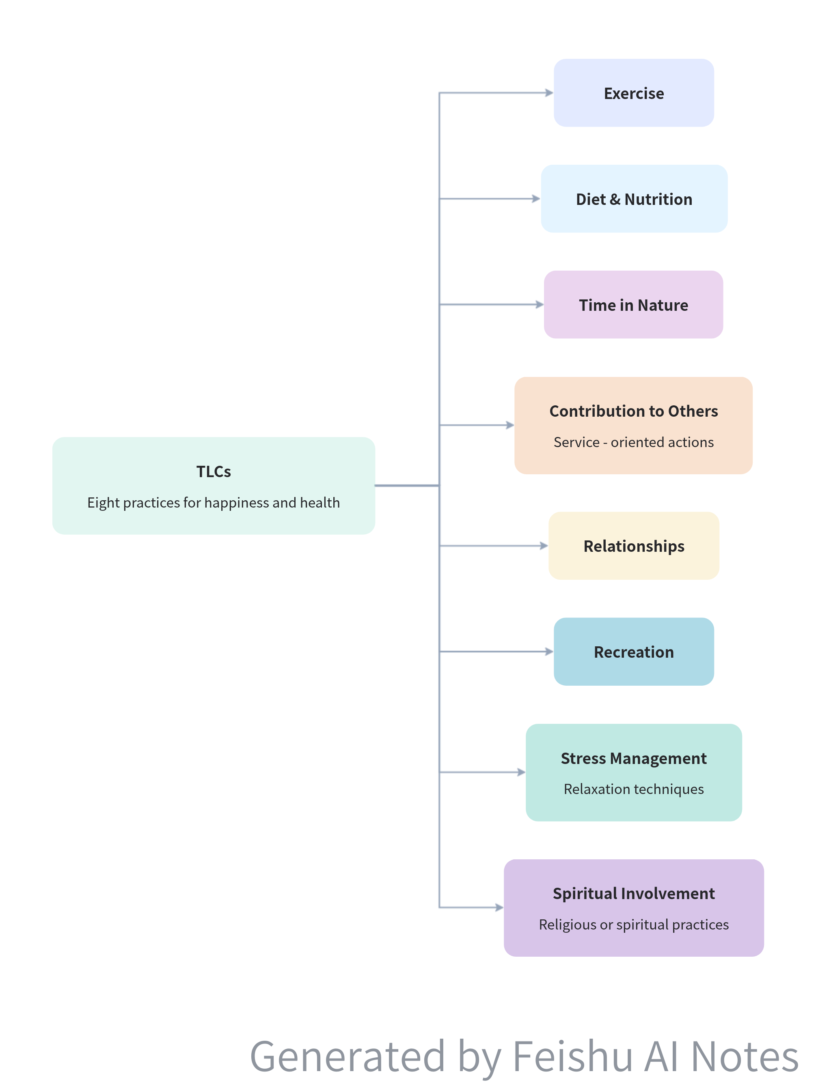  Therapeutic Lifestyle Changes (TLCs) Framework
- Importance of Communication Skills
- Value in the Workplace: The boy mentioned that he learned communication skills during his non - traditional learning process. Speaker 1 pointed out that communication skills rank first among the skills most valued by enterprises globally.
- Lack in Traditional Education: Despite its importance, there is often no dedicated course in traditional schools to teach communication skills. Standard communication skills courses usually involve accurately presenting given materials to others to test expression ability.
[该类型的内容暂不支持下载]

智能章节
00:02 Kids' Perspectives on Growth and Happiness
Speaker 1 suggests watching a video about how a boy views growth, saying it's inspiring for Chinese parents. Speaker 2 mentions that kids are often asked what they want to be when they grow up, and their answers usually differ from adults' expectations. A kid might simply want to be happy. As a teenager, Speaker 2 spends time on common teen concerns like messy rooms, showers, and getting girls to like him.
01:54 The Peculiarities of the Teenage Brain and the Lack of Focus on Happiness and Health in Schools
The teenage brain is unique with an underdeveloped prefrontal cortex and more neurons than adults, leading to creativity, impulsiveness, and moodiness. Many kids today simply wish to be happy, healthy, safe, unbullied, and loved. Adults often assume kids will achieve these by following a typical life path, but schools don't prioritize teaching how to be happy and healthy, and for some kids, this knowledge doesn't exist.
02:43 Education Should Be Based on the Practice of Being Happy and Healthy
Speaker 2 questions the traditional separation of education from the study and practice of happiness and health. They argue that being happy and healthy is a simple practice and should be regarded as a part of education. Since they can't understand why it's not considered as such, they've been studying the science of being happy and healthy.
03:06 Eight Therapeutic Lifestyle Changes for Happiness and Health
Speaker 2 mentions eight things—exercise, diet, etc., known as therapeutic lifestyle changes (TLCs) from Dr. Roger Wash, a scientist researching happiness and health. When asked if schools prioritize these TLCs, Wash said no. He noted that many seek this education outside traditional settings like through meditation or yoga. His best response was that much of education focuses on making a living rather than making a life.
04:07 Sir Ken Robinson's TED Talk Inspires Educational Revolution but Faces Resistance
In 2006, Sir Ken Robinson's Ted talk "Schools kill creativity" became the most popular one. His message that creativity is as important as literacy influenced many parents. Some, like the speaker's, were confident to pull their kids from traditional school. The speaker is part of a small but growing educational revolution. Despite facing peer pressure, the speaker's mom didn't cave. The speaker wonders why there aren't more kids like them among the 200 million viewers of the talk.
05:07 Shane Mcconky: A Skiing Hero and Hacker Who Transformed Skiing
Speaker 2 regards Shane Mcconky as their hero. Initially, the reason was that Mcconky was the world's best skier. Later, the speaker realized they truly admired him because he was a "hacker" (not a computer one). His creativity and inventions shaped skiing into what it is today, which is why the speaker loves skiing.
05:26 The Value of the Hacker Mindset
Speaker 2 challenges the common view of hackers as basement - dwelling virus - spreaders. Instead, they define hackers as innovators with a unique mindset, those who challenge and change systems to make them work better. The speaker believes the world needs more people with this hacker mindset, not just in technology. They note that everything, like skiing and education, can be "hacked," and figures like Steve Jobs and Mark Zuckerberg show that this mindset can change the world.
06:06 Hack Schooling: A Flexible, Opportunistic Learning Mindset
Speaker 2 introduces "hack schooling," which is a significant part of their education focusing on health, happiness, and creativity. They don't follow a specific curriculum or approach but hack their education. They seize community and network opportunities, experience learning, and seek shortcuts. It's a flexible, opportunistic learning remix prioritizing well - being and creativity. Since it's a mindset, not a system, anyone, including traditional schools, can use it.
06:56 My Diverse Learning Experiences and Educational Programs
The speaker shares their educational experiences. They study common subjects but got to write about personal interests at Squaw Valley Kids Institute, which sparked their love for writing. They had fun hacking physics with experiments. The Project Discovery's ropes course taught them to handle fears and trust others. Community programs like High Fives Foundations Basics and Squaw Valley Ski Patrol focused on safety. Young Chautauqua brought history alive by performing as famous historical characters.
09:09 The Significance and Joys of Weekly Wilderness Survival Classes
Speaker 2 emphasizes the importance of time and nature, stating it offers calm and an escape from reality. They spend one day a week at foxwalker classes outdoors. The goal is to survive in the wilderness with just a knife. They learn to listen to nature, sense surroundings, and have developed a spiritual connection. The best part includes making spears, bows and arrows, starting fires with a bow drill, and building survival shelters during camping in snowy nights.
09:43 Inspiration from Factory Internship and Contributions at Big Truck Brand
The speaker was inspired by the moment factory where skis are handmade and clothes designed, and wants to have their own business one day. They learned they need to be good at math, creative, and sewing from the factory workers. They got an internship at Big Truck Brand, and despite menial tasks, they're contributing to clothing design, customizing hats, and selling them. The people there are in high spirits, and this is the speaker's favorite class.
10:20 Skiing, Education, and the Pursuit of Happiness
Speaker 2 says Saturdays on the mountain are a happy time and a metaphor for life, education, and "hack schooling." They contrast typical skiing paths with seeing a thousand possibilities, stating that skiing and education represent freedom, creativity, and community. The speaker is starting to think about their future career but always wants to be happy.
11:25 The Root Cause of Lack of Learning Motivation: Unpleasant Learning Methods
The speaker plays a video of an 11 - year - old boy expressing his views on learning. The boy says he loves learning but in his preferred way, not the one imposed by parents. This shows the real reason for the lack of learning motivation is the wrong learning approach. The speaker also mentions that both kids and adults pursue happiness, whether it's in learning, employment or daily gossip, and concludes that everyone loves learning in their favored way.
14:37 Importance of Communication Skills and Motivation Shaping
The speaker discusses a child in a video who learned skills at school, with the first being communication. Communication is ranked the most important skill by global enterprises, yet few school courses teach it. Standard communication courses focus on accurate information expression. The speaker also mentions motivation, including primary motivation and a way to create motivation in the uninterested, and starts to tell a story of an old man dealing with kids throwing stones.
[该类型的内容暂不支持下载]

关键决策
This meeting is a sharing session without any key decisions. The key points of the meeting are summarized as follows:
- Children's Views on Growth and Learning: The video shows that children's answers to "what do you want to be when you grow up" often differ from adults' expectations. They want to be happy and prefer learning in their own way. Traditional education may not prioritize teaching children how to be happy and healthy.
- The Concept of Hack Schooling: The speaker advocates for a "hack schooling" approach, which is flexible, opportunistic, and focuses on making happiness, health, and creativity a priority. It encourages children to take advantage of various opportunities and not be restricted by a single curriculum.
- Skills Learned in Non - traditional Education: The child in the video learned important skills such as communication, handling stress, and working efficiently through non - traditional educational experiences. Communication is emphasized as a crucial corporate skill that is often lacking in traditional school curriculums.
[该类型的内容暂不支持下载]

金句时刻
「When I grow up, I wanna be happy for me. When I grow up, I wanna continue to be happy like I am now.」
—— 说话人 2，This quote directly expresses the core view of the child's attitude towards growth, emphasizing the pursuit of personal happiness, which is a simple and profound concept that can trigger people's thinking about the meaning of growth.

「Much of education is oriented, for better or worse, towards making a living rather than making a life.」
—— 说话人 2，This statement provides a unique insight into the current state of education, pointing out that education often focuses on livelihood rather than a fulfilling life, which is thought - provoking.

「Whether it's Steve Jobs, Mark Zuckerberg or Shane Mcconky, having the hacker mindset can change the world.」
—— 说话人 2，This quote highlights the importance of the hacker mindset, which is not only applicable to technology but also to various fields, inspiring people to be innovative and change - makers.
[该类型的内容暂不支持下载]

相关链接
- 妙记：56、男孩自述：小孩如何看待学习
- 文字记录
- 56、男孩自述：小孩如何看待学习 2026年1月22日

